Training and Test Site

- The tests and training will be held at Poole Knobs WMA
- 386 Old Jones Mill Road, LaVergne, TN, 37022

We will meet each morning at the Pavilion

(near the entrance to the training area)

Lodging
Host Hotel:
La Quinta Inn and Suites by Wyndham
2537 Highwood Blvd, Smyrna, TN 37167
615-220-8845
Block Code: CCRC $129 + tax per night plus $75 pet fee for the entire stay. Room Block covers May 22-26.

Camping

Poole Knobs Campground
493 Jones Mill Rd, La Vergne, TN 37086
Make reservations online at the following link:
https://www.recreation.gov/camping/campgrounds/232677
or by phone at 615-459-6948

A limited number of camping spots are available at the Pavilion near the Test and Training grounds (not in the campground). The rate for these spots with electric only is $15/nt. Priority given to RVs for these spots. Contact MaryAnn Minner (crzy@comcast.net) to reserve a spot in the Pavilion lot.

Refunds
Refunds will be made for dogs with a vet note after committee approval.

Curly-Coated Retriever Club of America

Curlyville 2025
Working Tests (WC/WCX/WCQ)
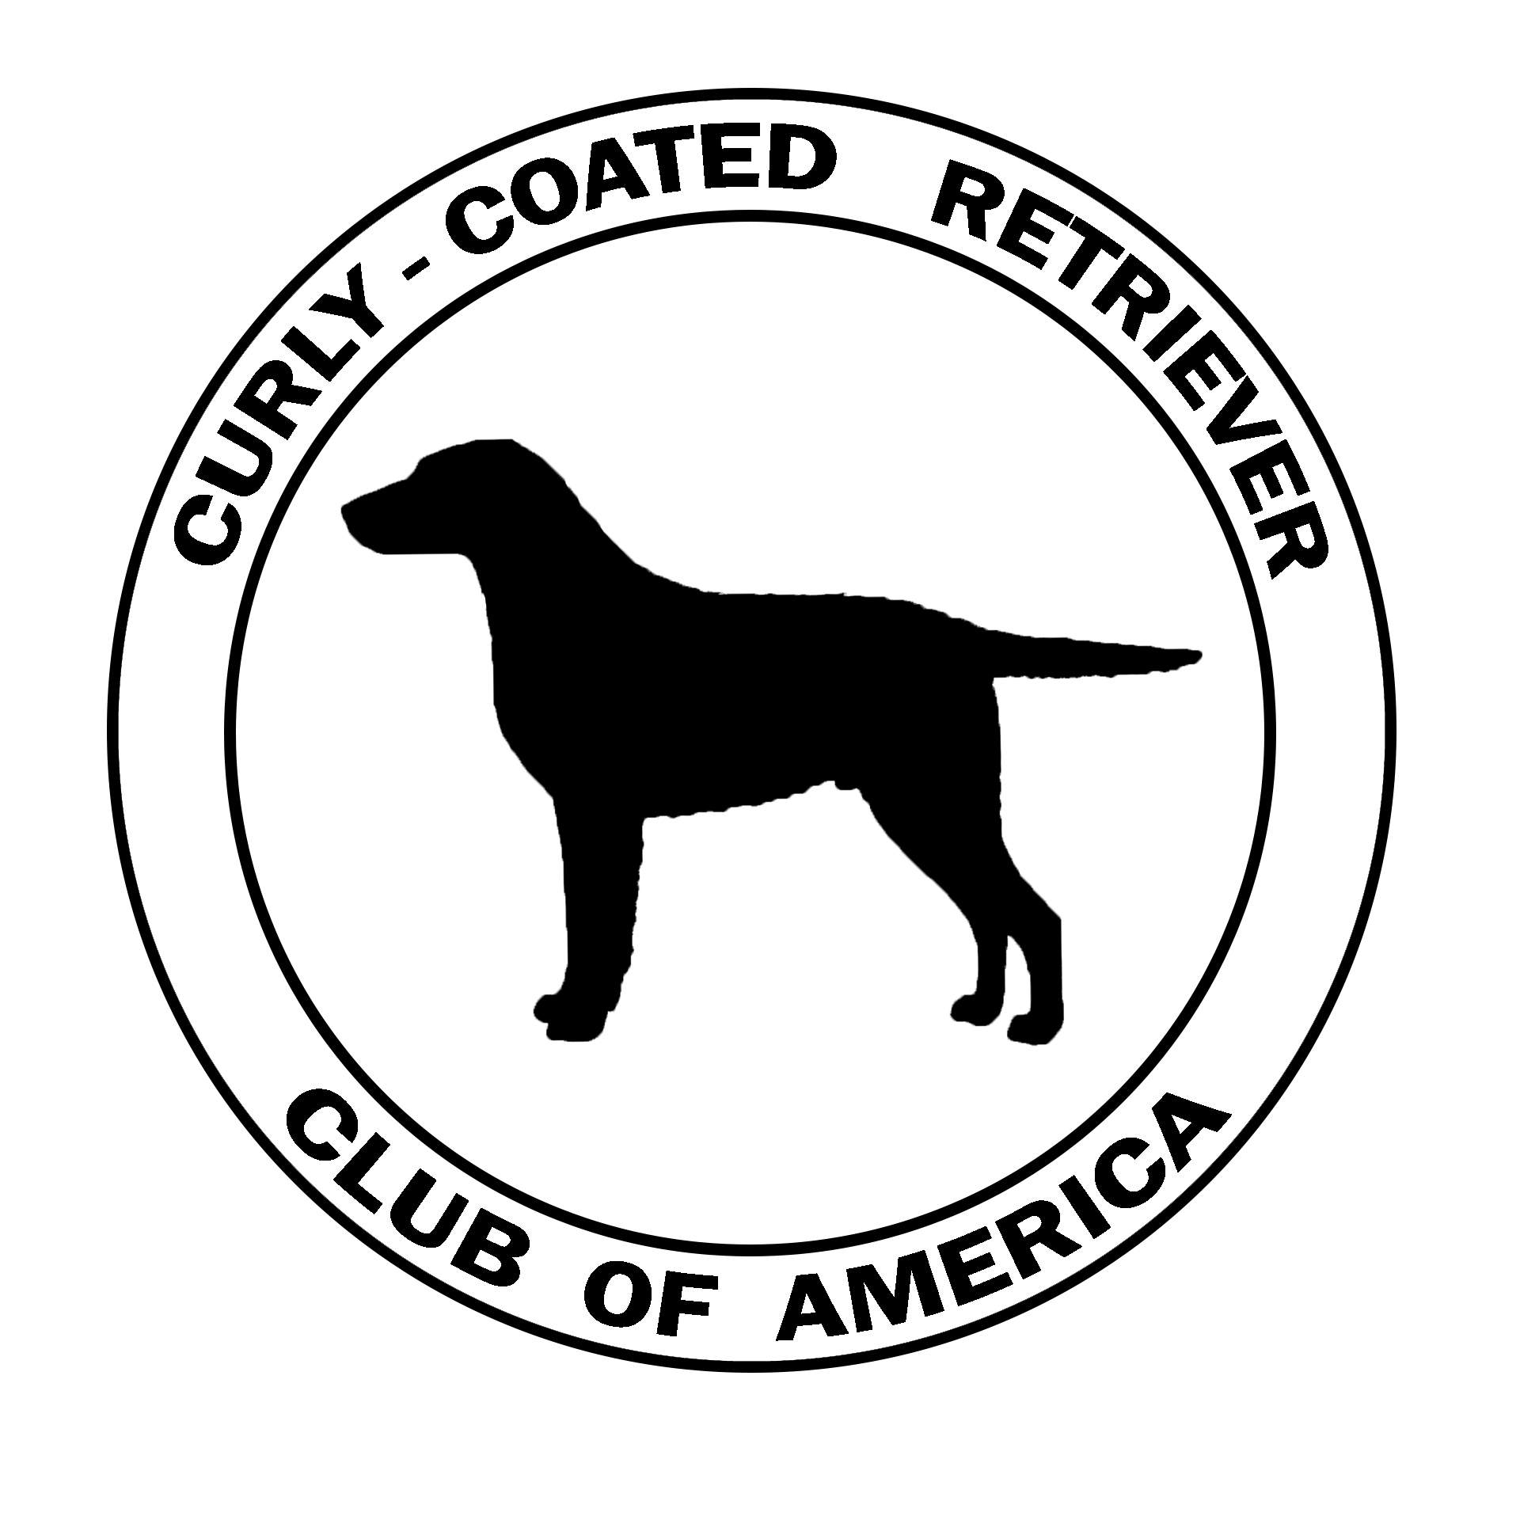

WC / WCX / WCQ Test Saturday, May 24, 2025
Training Days May 22nd and May 23rd
Entry deadline May 9th
(no late WCX or WCQ entries accepted, late training and/or WC entries are accepted but entries will not be reflected in the Catalog)

Poole Knobs WMA
386 Old Jones Mill Road
LaVergne, TN

Training starts at 8:30 AM Thursday and Friday
Check in at 7:00 AM Saturday
Tests Start at 8:00 AM Saturday

*Pre-Entries must be received by May 9th. Working Certificate (WC) test entries will be accepted on site through 6pm Friday May 23rd, subject to time/space limitations. See event secretary for on-site WC entry. Late entries for WCX and WCQ will not be accepted.

Information also available:
On Facebook Event Page “2025 Curlyville”
And CCRCA.ORG
Hunt Test Committee

Mary Ann Minner……………………………… Committee member
Carolyn Curtis .…………………………… Committee member
Jenni Harms ……………………………. Committee member
Kathy Kail………………………................. Event Secretary
Kathy Kail <curlcoat@earthlink.net>

Judges
To be determined.

Birds

Retrieving – Land and Water………………..Ducks
Dead ducks will be used in all stakes.

Rules

The rules for each event can be found on the CCRCA website: http://www.ccrca.org/downloads/wc_rules.pdf or upon request from the Event Secretary. Rules will also be available at the test site.

Bitches in Season
CCRCA rules as of the event date will apply with respect to eligibility of Bitches in season to participate in the Working Tests. As of premium publication, bitches in season may run after all other dogs have run.

Scratches
There will be no refunds for scratches for any other reason. These are retrievers being tested for work in natural conditions, and the CCRCA will not entertain requests for refund due to issues such as not liking the grounds or test set up. It is the responsibility of all entrants to familiarize themselves with the local natural environment.
Training Sessions
Training begins at 8:30a on Thursday, and Friday. Attendance at training is not a requirement for entry to the WC/WCX/WCQ tests. Conversely, you can attend training and not enter a test.

Entry Fees
Working Tests
WC $45
WCX $55
WCQ $55
Training Days ………………………$10/dog/day

This event is intended for Curly-Coated Retrievers. Other breeds welcome if limits not met. Contact Event Secretary for approval.

Please make checks payable to CCRCA and mail entry form and payment to Kathy Kail, 202 West Stevens, Santa Ana, CA 92707. Phone 714-501-9749
To arrive by Friday, May 9th.
PayPal is available, go to CCRCA.ORG for the link.
If using PayPal, entry form must be emailed to the Event Secretary.

Awards to Qualifying Dogs
WC / WCX / WCQ Rosettes, Leg Bands, Certificate*

*Non-CCRCA members awarded a WC/WCX/WCQQ certificate upon payment of a $5.00 fee. Non-Curly qualifiers will not be awarded certificates, but will receive rosettes.

Meals
Group meals are planned as follows:
Friday 530p BBQ, Raffle/Silent Auction, Poole Knobs Pavilion ($17/pp)
Saturday (test day) sub sandwiches lunch ($13/pp)
Saturday night Banquet 6p Logans Roadhouse 600 Sam Ridley Pkwy W, Smyrna TN (615) 220-2780

Auction
An Auction is planned for Friday night at the barbeque, proceeds help cover event costs. Your raffle donations are appreciated!
Please Volunteer!
There are more volunteer slots than attendees, so feel free to sign up for more
than one thing!

(Print your name here)
Make check payable to CCRCA. Entries must be received by May 9th. Mail to: Kathy Kail, 202 West Stevens, Santa Ana, CA 92707
To pay using PayPal, see the Curlyville information on CCRCA.ORG for the link. If using PayPal, entry form must be emailed to the Event Secretary, curlcoat@earthlink.com

Training (Cost: $10/dog/day)
Training Thursday May 23 _____ #dogs @$10/dog = $_____
Training Friday May 24 _____ #dogs @$10/dog = $_____
Meals
BBQ Friday May 24 _____ #people @$17/pp = $_____
Lunch Saturday May 25 _____ #people @$13/pp = $_____
Banquet Saturday May 25 ____ _____ #people for rsvp
(Saturday night dinner is individual checks)
Saturday, May 25 Working Certificate Tests
Day of entry Working Certificate will be $55.00
Working Certificate- WC _____ #dogs @$45/dog = $_____
Working Certificate.Excellent-WCX _____ #dogs @$55/dog = $_____
Working Certificate Qualified-WCQ _____ #dogs @$55/dog = $_____
TOTAL SUBMITTED $______
ENTRY FORM
Please write legibly
TEST LEVEL: WC WCX WCQ If entering WCQ, indicate number
Training ONLY of passes previously earned______

REGISTERED NAME (AKC titles only) _________________________________________

CALL NAME ________________ AKC REG # ___________________COLOR_________

BREEDER ______________________________________ DATE OF BIRTH____________

SIRE ___________________________________ DAM ______________________________

OWNER(S) _____________________________ HANDLER__________________________
CHECK BOX IF JUNIOR HANDLER
- - - - - - - - - - - - - - - - - - - - - - - - - - - - - - - - - - - - - - - - - - - - - - - - - - - - - - - - - - - - - - - - - - - - - - - - -
TEST LEVEL: WC WCX WCQ If entering WCQ, indicate number
Training ONLY of passes previously earned______

REGISTERED NAME (AKC titles only) __________________________________________

CALL NAME ________________ AKC REG # ___________________COLOR_________

BREEDER ______________________________________ DATE OF BIRTH____________

SIRE ___________________________________ DAM ______________________________

OWNER(S) _____________________________ HANDLER__________________________
CHECK BOX IF JUNIOR HANDLER
- - - - - - - - - - - - - - - - - - - - - - - - - - - - - - - - - - - - - - - - - - - - - - - - - - - - - - - - - - - - - - - - - - - - - - - - -
TEST LEVEL: WC WCX WCQ If entering WCQ, indicate number
Training ONLY of passes previously earned ______

REGISTERED NAME (AKC titles only) __________________________________________

CALL NAME ________________ AKC REG # ___________________COLOR_________

BREEDER ______________________________________ DATE OF BIRTH____________

SIRE ___________________________________ DAM ______________________________

OWNER(S) _____________________________ HANDLER__________________________
CHECK BOX IF JUNIOR HANDLER
- - - - - - - - - - - - - - - - - - - - - - - - - - - - - - - - - - - - - - - - - - - - - - - - - - - - - - - - - - - - - - - - - - - - - - - - -
I certify that I am the actual owner of the dog or that I am the duly authorized agent of the actual owner whose name I have entered above. In consideration of the acceptance of this entry, I (we) agree to abide by the rules of the CCRCA in effect at the time of this event. I (we) agree to hold the CCRCA, its officers, representatives, and members harmless from any claims of loss or damages resulting from our voluntary participation in this event.

SIGNATURE _____________________________________________________________

CELL PHONE ___________________________EMAIL___________________________

