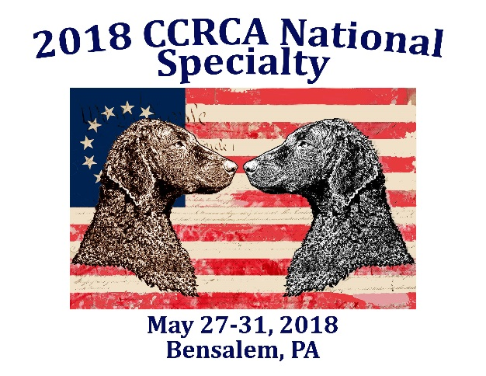
Meal Options and Form
Sunday Field Lunch
Wawa 6 Inch Hoagies (Subs for those that don’t know)
Choices are: Turkey, Italian, Tuna
Lettuce & Tomato will be on the hoagie. Condiments will be on the side.
Will have Chips and drinks
Cost: $8
Field Awards Dinner
Location: Host Hotel
Time: 6:30PM
Meal:
Pulled Pork/BBQ Chicken Breast
Creamy Macaroni and Cheese
Homemade Cole Slaw
Rolls
There is a cash bar on site that will be open
Cost: $22
Come join us for a barbeque dinner after playing all day on the field. Congratulate the winners of the day, relive some funny moments, celebrate new titles and just relax!
Monday Agility Day
Lunch is on your own. There is a concession stand on site.
Tuesday
On your own for meals today
Wednesday Performance Luncheon
Location: Host Hotel, Outside (Weather permitted)
Time: At the conclusion of Rally and Obedience
Meal:
Made Your Own Sandwich Tray
(Tuna Salad, Chicken Salad, Hot Roast Beef in Gravy, American, Provolone)
Homemade Pasta Salad
Homemade Cole Slaw
Caesar Salad
Sliced Seasonal Melon
Beverages (Water, Iced Tea, Lemonade, Soda)
Cost: $20
All performance events have concluded but the show is not over. Don’t forget those Versatility Challenges!
Thursday
Light Snacks and Drinks will be provided all day long
Annual Awards Banquet
Location: Host Hotel, Emerald Ballroom
Time: 6pm Cocktails 7pm Dinner (Depends on when Conformation Finishes up)
Meal:
Chicken Stuffed with Spinach and Fontina
Hot Roast Beef in Gravy
Penne Pasta w/Vodka Blush
Seasonal Vegetable
Mixed Green Salad w/Assorted Dressing
Rolls and Butter Tray
Coffee and Tea w/Condiments
Cost: $29 (Book Early as space is LIMITED)
The show has ended, but the fun has not! Come join us for the annual banquet. Annual Awards will be given out, raffles and auctions will be going on, fun to be had. Celebrate and learn a Philadelphia New Year’s Day tradition. Enjoy the costumes, the music, and the scenery.
Form to be scanned, emailed, or sent via Snail Mail to Althea Donovan
http://www.ccrca.org/specialties/2018/2018SpecialtyMeals.html
Checks payable to CCRCA. PayPal: Just send an email to Althea to let her know you paid by PayPal. You must still send a form to Althea!
PayPal Users: There is an additional 3.5% Fee that will be added to all PayPal Transactions.
doktord@aol.com 555 Spring Oak Drive N West Chester, PA 19382
NAME(S):____________________________________________________________________________
ADDRESS:_____________________________________________________________________________
PHONE NUMBER & EMAIL ADDRESS (ES):_______________________________________________________________________ Please if you have any food allergies and or questions about meals let me know so we can accommodate you as best as we can! You may email me to ask.
How many? Cost: Total:
Field Lunch:
_____________________________ ____________ ________ ______
Field Dinner:
_____________________________ ____________ ________ ______
Performance Lunch:
_____________________________ ____________ ________ _______

Annual Awards Dinner:
_____________________________ ____________ ________ _______

Total Meals ___________________

Total Cost ___________________

