2015 CCRCA Specialty Shirts
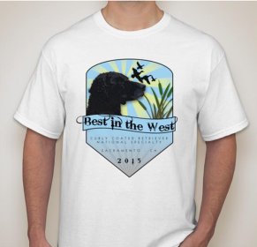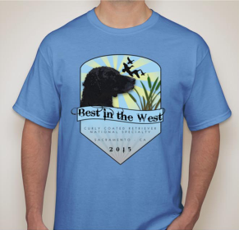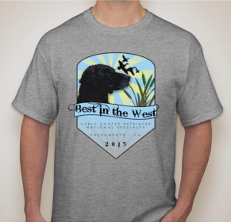
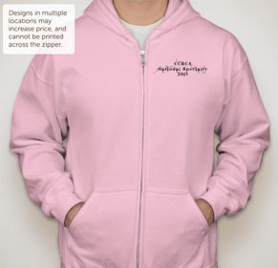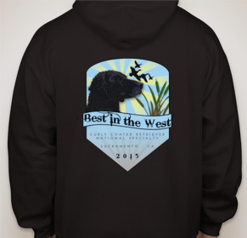
Youth - Adult: YXS, YS, YM, YL, YXL, S, M, L, XL, 2XL, 3XL, 4XL (add $5 for 2XL or larger) -$25 each
Sweatshirt: S, M, L, XL, 2XL – $45 each

Optional Shirt Colors: White/Blue/Grey
Pink/Black

Checks payable to CCRCA & Mail To:
Iris Andre
8603 Quartzite Circle
Granite Bay, CA 95746

Quantity Size Youth/Adult/Ladies Color Unit Price Total
 |  | Order Deadline September 1, 2015 |  | S&H
 |  |  |  | Total Due
- I will pick up my shirt(s) at the National Specialty
- I would like my shirt(s) mailed (S&H $5 each)
Ship To:
Name: _______________________________________________________________

Address: _____________________________________________________________

____________________________________________________________

Order Confirmation E-Mail: ____________________________________________________

